Exploration Game

Exploration Game is a simple game about exploring and obtaining resources. The game has four main menus (refers to Figure 1), they are:

1. Explore the Woods!
2. Exploration Records
3. Clear Exploration Record
4. Exit



Figure . Screenshot of Main Menu

Array data type will be used to store the game data. Your task is to create this game in C Programming language based on the following requirements:

1. Menu 1 – Explore the Woods!

Player can access this menu to start exploring the woods. When the player chooses this menu (refers to Figure 2):

* The program will ask the player to input exploration type. The input must be “hunting” or “gathering” (case sensitive).
* The program will ask the user to input exploration duration in hours. The input must be between 1 and 3.
* If the player chooses “hunting”:
* The program will calculate number of furs obtained using below formula:

**Furs obtained = (Random Value between 0 and 10) \* exploration durations**

* The program will calculate number of meats obtained using below formula:

**Meats obtained = (Random Value between 0 and 5) \* exploration durations**

* If the player chooses “gathering”:
* The program will calculate number of firewood obtained using below formula:

**Firewood obtained = (Random Value between 0 and 100) \* exploration durations**

* The program will calculate number of herbs obtained using below formula:

**Herbs obtained = (Random Value between 0 and 5) \* exploration durations**

* The program will display the exploration result and keep a record of it. The exploration record must contain the exploration type and the resources obtained for each exploration.

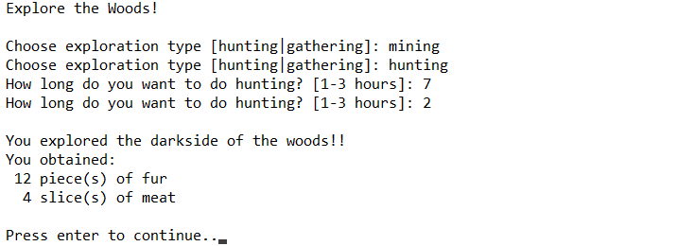

Figure . Screenshot of “Explore the Woods!” Menu

1. Menu 2 – Exploration Records

Player can access this menu to view their exploration records, refers to Figure 3.

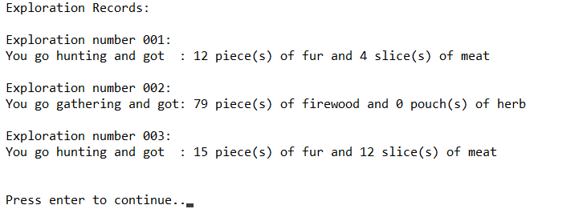

Figure . Screenshot of “Exploration Records” Menu

1. Menu 3 – Clear Exploration Record

Player can access this menu to clear all exploration records, refers to Figure 4.



Figure . Screenshot of “Clear Exploration Record” Menu

1. Menu 4 – Exit

Player can access this menu to exit from the game, refers to Figure 5.



Figure . Screenshot of “Exit” Menu